New Database Setup:
1. Install [mysql-8.4.4-winx64.msi]
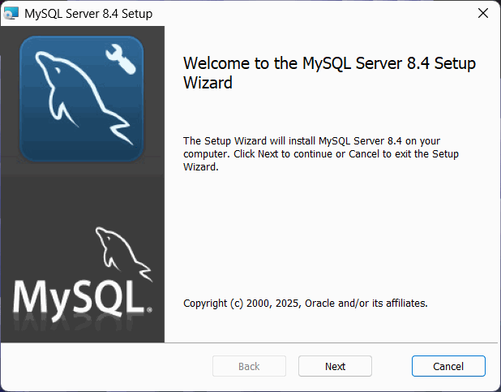
2. Run MySQL Configurator
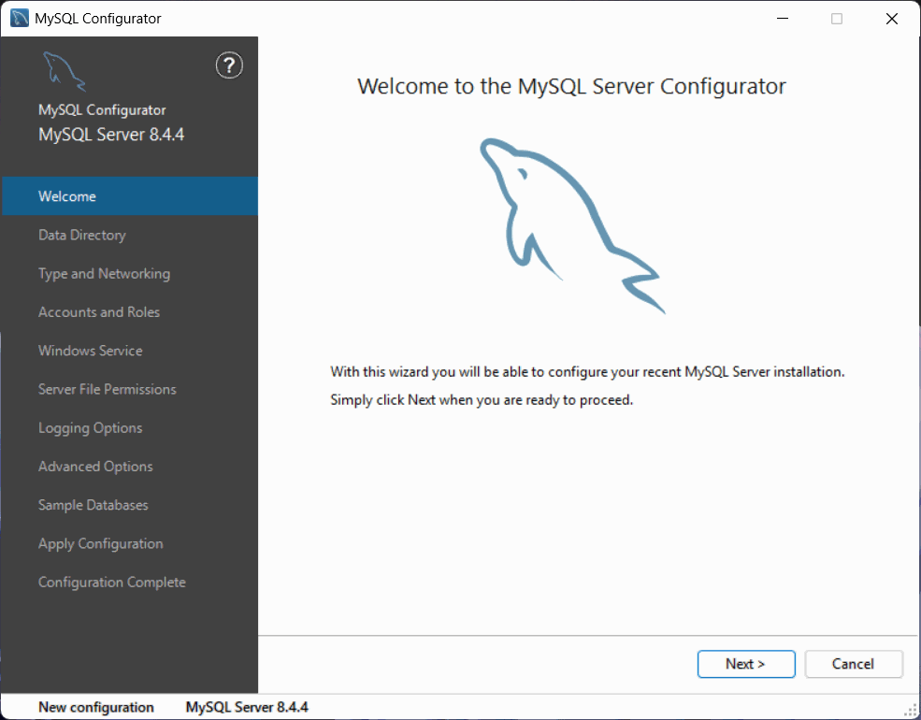

3. Install [mysql-workbench-community-8.0.41-winx64.msi] and open MySQL Workbench 8.0 CE
4. Select Local instance MySQL84 (if not detected itself, may need to add by yourself.)
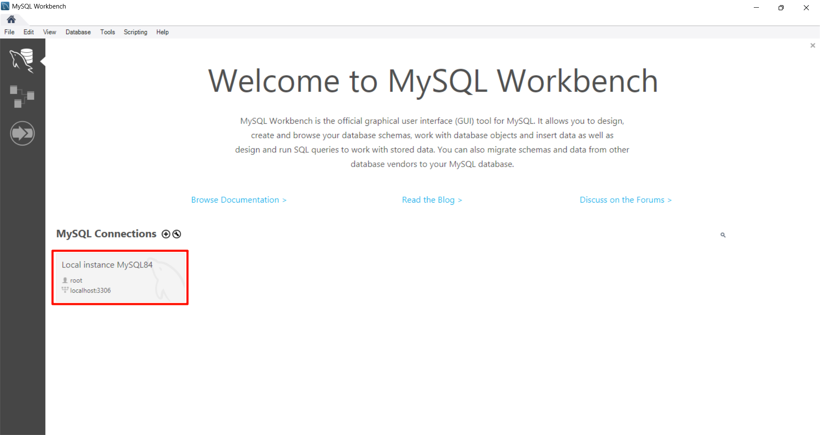
4. Password: root
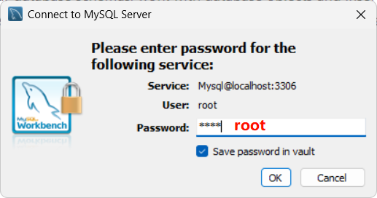

5. Import queryTable.sql
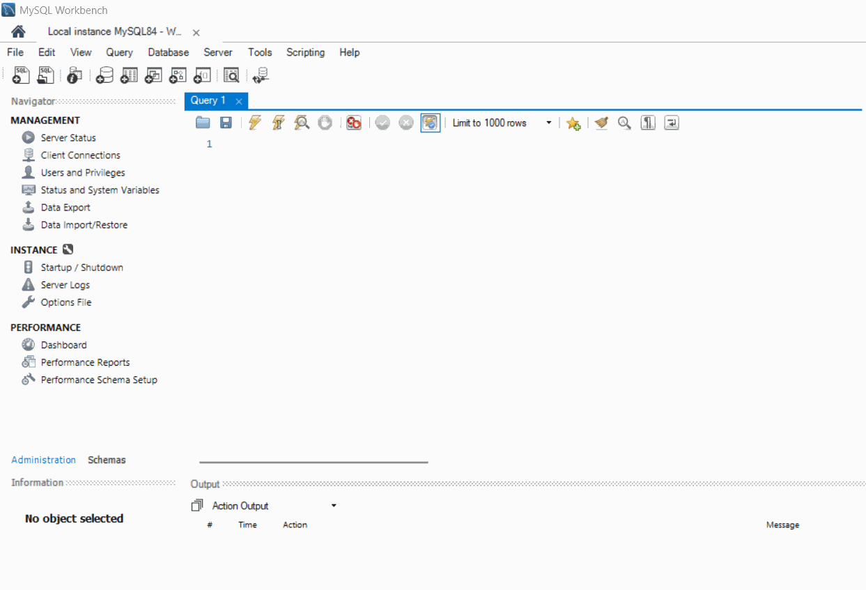
6. Import queryImport.sql
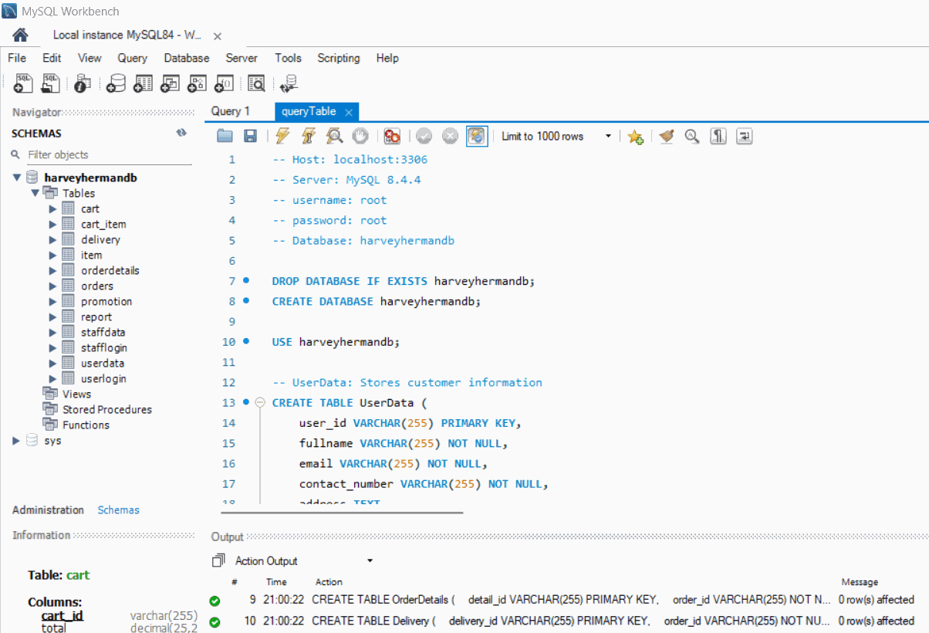
New Server Setup:
1. Go to GlassFish Server 5.1.0’s admin console
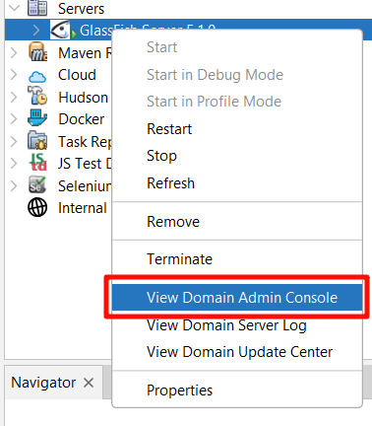
2. Domain > Applications Configuration
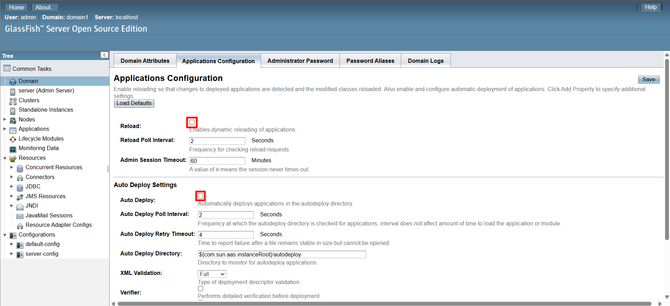

3. Resources > JDBC > JDBC Connection Pools > New…
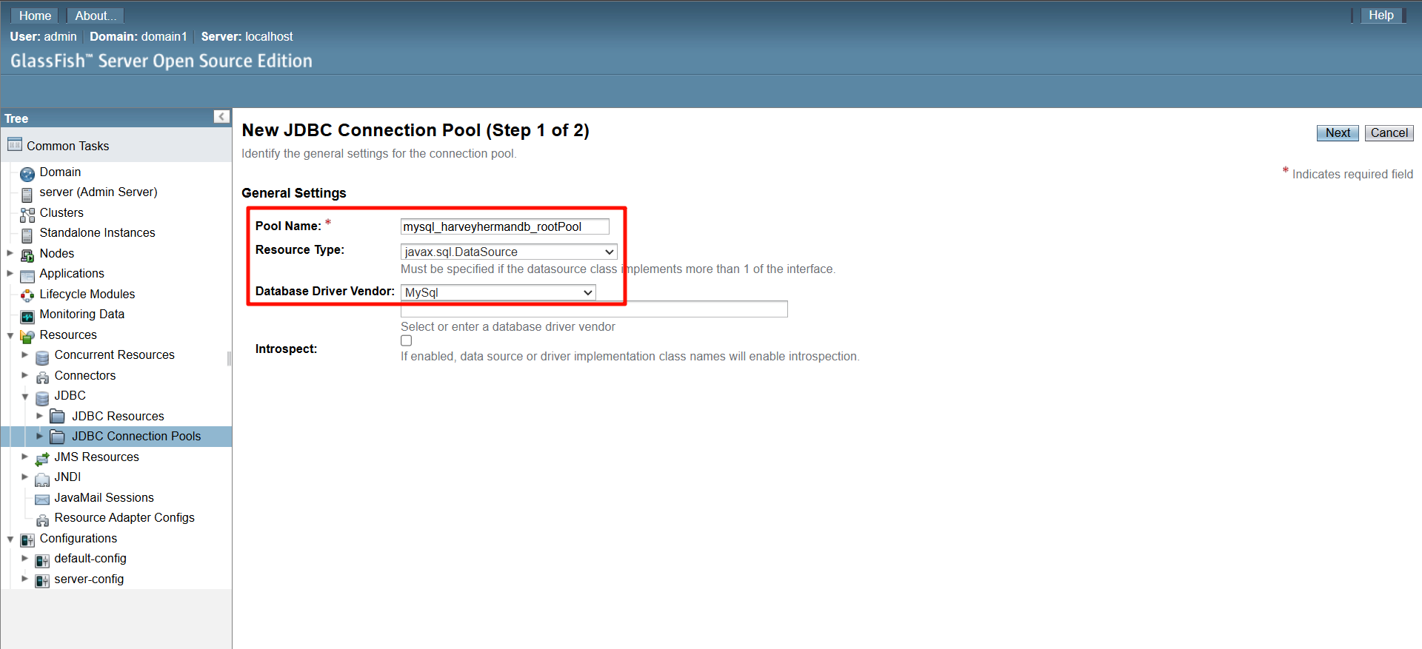
4. Next
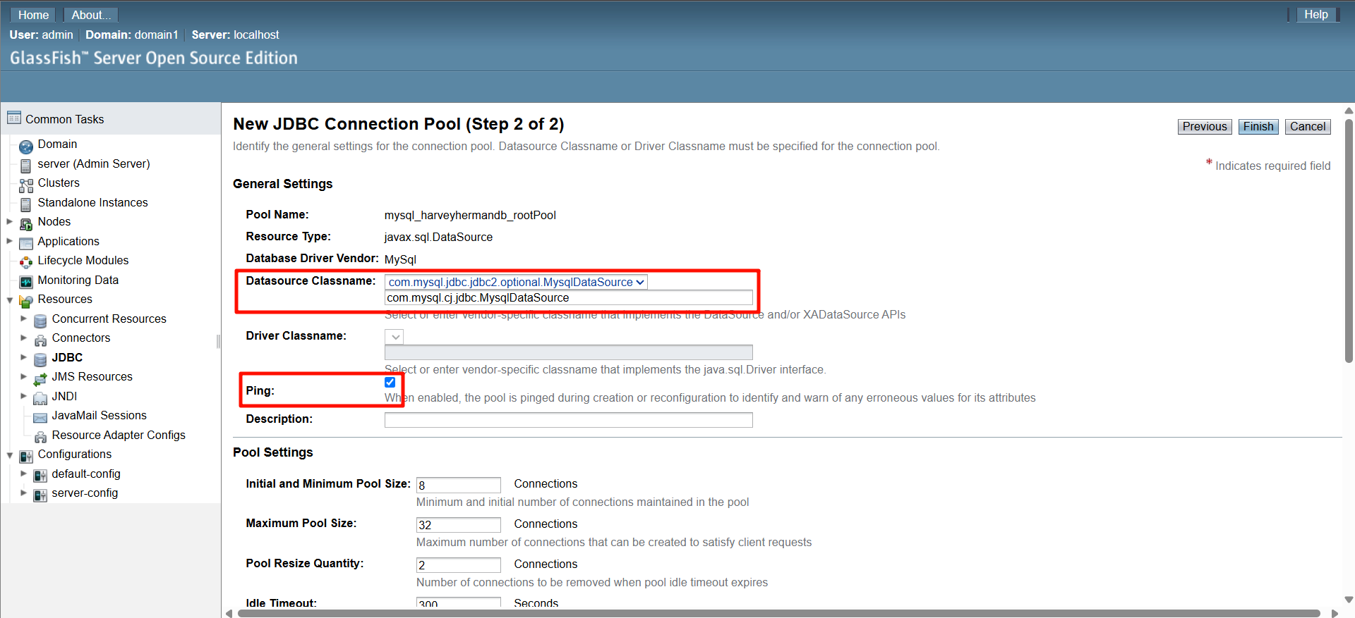

5. Scroll down
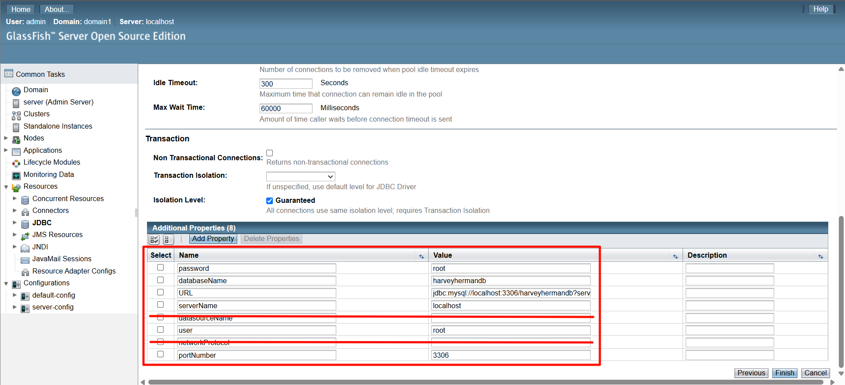
6. Save. Go to Resources > JDBC > JDBC Resources > New…
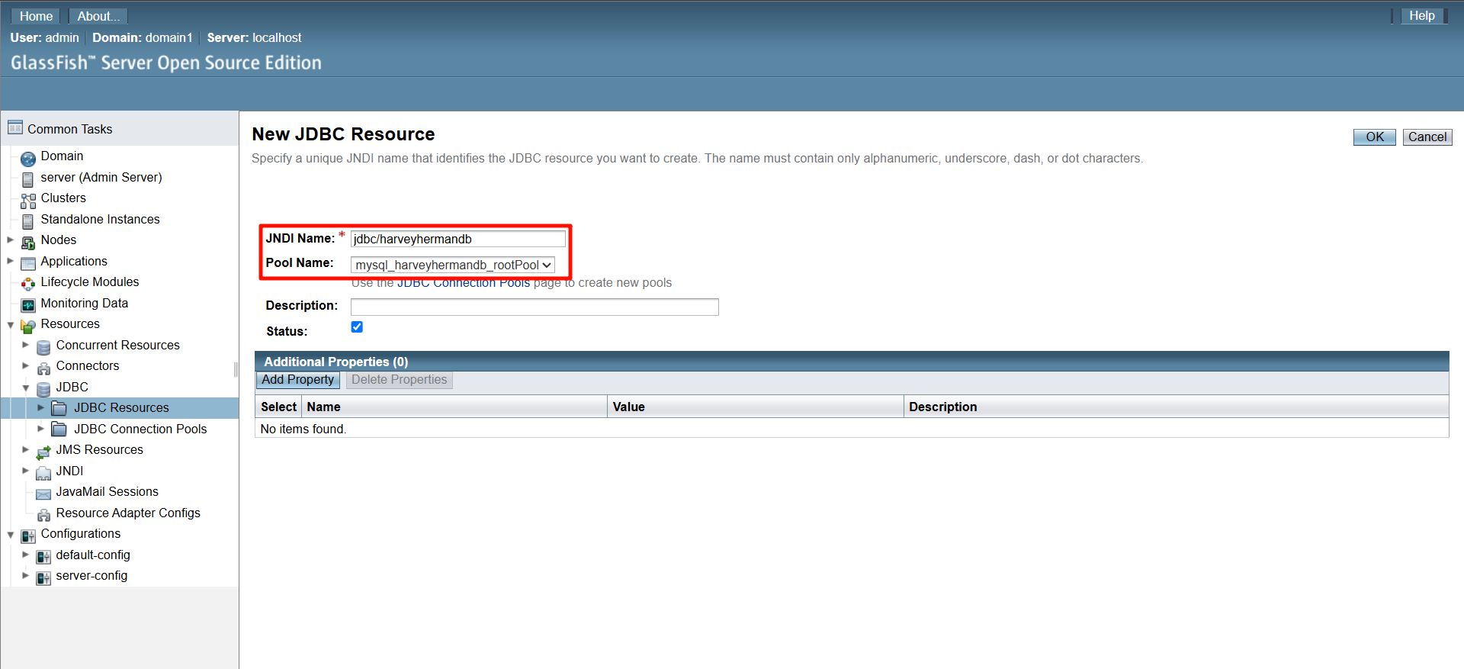7. Save.

8. Copy mysql-connector-j-9.2.0.jar
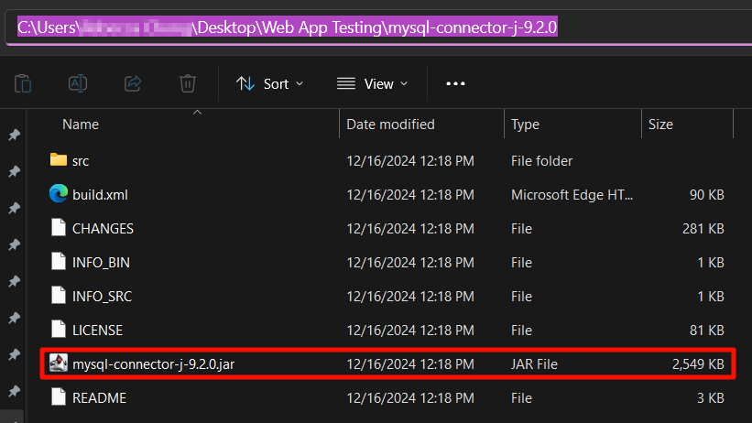
9. Paste to Server domain’s lib
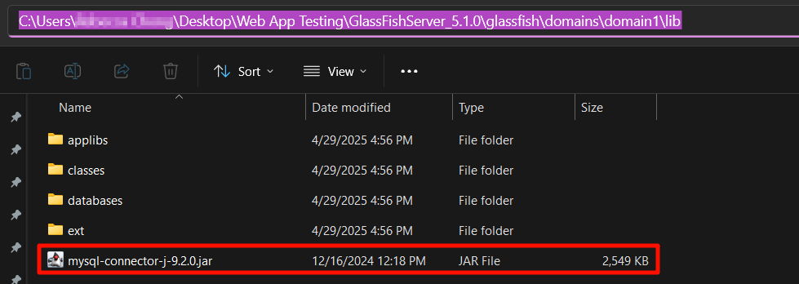

New Project Setup:
1. Make sure the GlassFish Server 5.1.0 you have just setup was imported in NetBeans IDE > Services > Servers
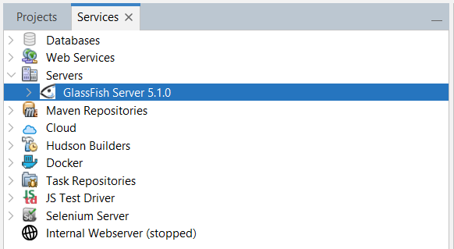
2. Open HarveyHerman project
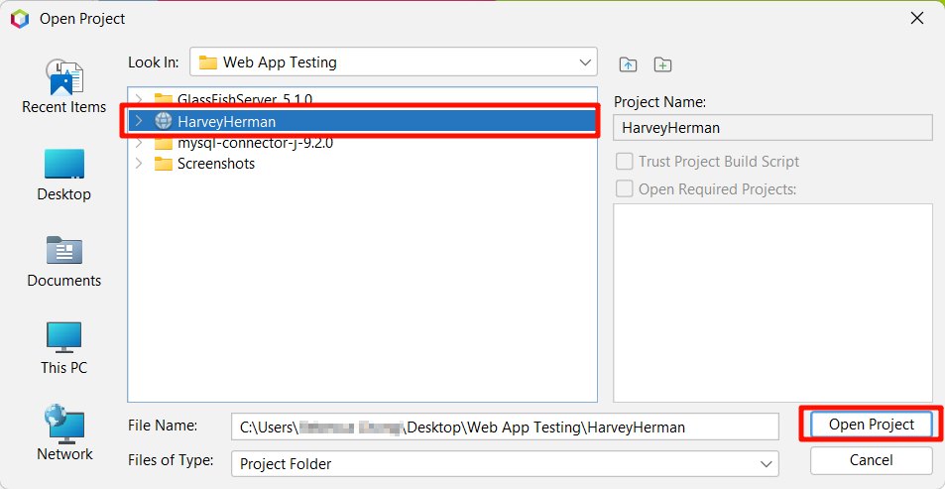
3. Make sure the JDK and GlassFish Server
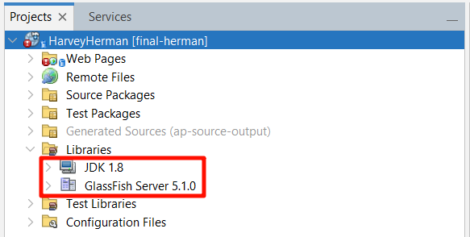
4. Clean and Build
5. Deploy
6. Run

